Management Team

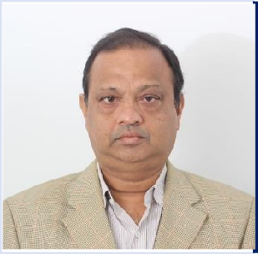Suman Ghosh

Managing Director

Mr. Ghosh completed his B.E. from Bengal Engineering College in 1991 . He is having more than 30 years of experience handling EPC Contracts by way of serving different Corporate Companies at various positions. He was with Civcon Constructions Pvt Ltd ,ISGEC JOHN THOMPSON,NICCO CORPORATION LTD, RAMKY INFRASTRUCTURE LTD

Kaushik Bhattacharya

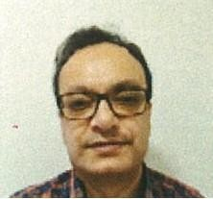

Chief Executive Officer

Mr. Bhattacharya completed his B.E. from Bengal Engineering College in 1991 . He is having more than 30 years of experience handling EPC Contracts by way of serving different Corporate Companies at various positions. He was with

Abhijit Roy

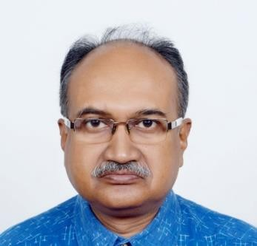

Sr Vice President- Civil & Architectural Division

Mr Roy completed his B.E. from Bengal Engineering College in 1987 . He is having more than 34 years of experience handling D&E, Housing & Hotel Contracts by way of serving different Corporate Companies at various positions. He had very much gracious presence with following professional houses serving various prestigious projects throughout India and Abroad. Ghosh,Bose & Associates, Development Consultants Ltd, Sanjeevani Estate Pvt Ltd, Fort Projects Pvt Ltd, Ambuja Housing & Urban Infrastructural Co Ltd, Mani Group.

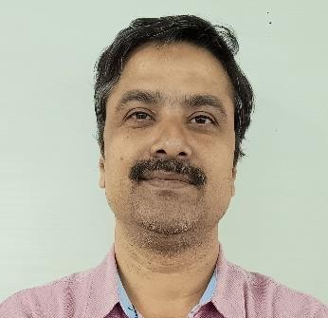

Soumyajit Ghosh

Director

Mr Ghosh completed his technical qualification in Civil Engineering in 2001(D.C.E.) from Jalpaiguri Polytechnic Institute. He is having more than 20 years experience in the fields of Reinforced Soil Structure, Building & Civil projects. He could serve various prestigious projects with companies like AIMIL Ltd, Reinforced Earth India Pvt Ltd, Maccaferri Environmental Solutions Pvt Ltd..

## Management Team

Debasish Chatterjee

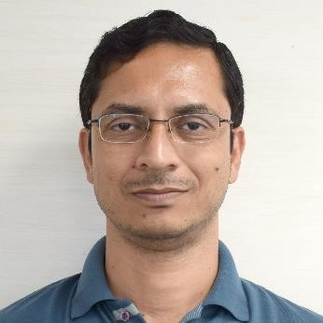

Director

Mr. Chatterjee completed his B.E. from Asansol Engineering College in 2002 . He is having more than 19years of experience handling EPC Contracts by way of serving different Corporate Companies at various positions. He is a Member of The Institute of Engineers and he is Chartered Engineer. He was with Bharat Heavy Electricals Ltd, ABB Ltd, DESCON Ltd, SPML Infra Ltd, Techno Electric & Engg Co Ltd.

Sankhanil Ghoshal

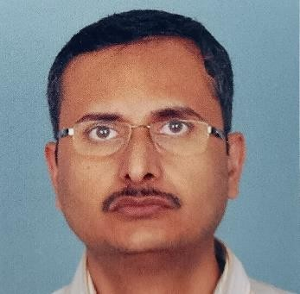

Director

Mr Ghoshal completed his technical qualification in Civil Engineering in 1995 from S.C.E.&T.C.,Diploma in Autocad from CCA in 1995,AMIE from Institute Of Engineers in 2000. He is having more than 25 years experience in the field of Architectural projects with various companies of repute. Key previous employers are Edifice Architect P Ltd, Bengal Ambuja Housing Development Ltd, Space Matrix Design P Ltd., Avani Projects and Infrastructure ltd., Acme Consultants Pvt. Ltd., Mani Group, Simoco .

Anjan Biswas

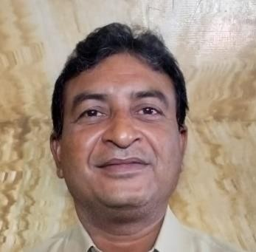

General Manager Projects

Mr Biswas completed his BE in mechanical from Bengal Engineering Collage in 1993. He is having more than 30 years of experience. He is also Certified Lead Auditor for ISO 9001. He was with

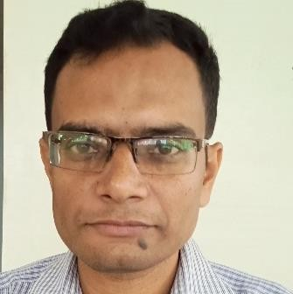

Mr. Sabyasachi Dutta

Dy. General Manager Projects

Mr Dutta Completed his BE in Mining Engineering from IIEST, Shibpur in 2005. He is having more than 18 years of experience in Mining and Bulk Material Handing Projects with HINDALCO and Sandvik Asia Limited.